**PANCAKES: Wheat**

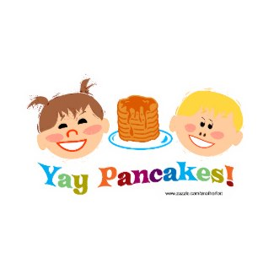**Ingredients:**

¾ c. mix

½ c. milk

2 teaspoons oil

1 egg

**Directions:**

1. Coat the griddle with cooking spray and heat until 375 degrees.
2. Mix your pancake mix, milk, oil, and egg in a bowl.
3. Use a whisk in order to get rid of the large bumps.
4. Pour about ¼ c. batter for each pancake onto your hot griddle.
5. Cook them 1-1.5 minutes each side or until they are golden brown.

**Set table, add a little syrup, and enjoy!**

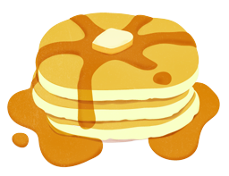

**PANCAKES: Blueberry**

**Ingredients:**

¾ c. mix

¾ c. milk

1 Tablespoon oil

1 egg

¼ c. Blueberries

**Directions:**

1. Coat the griddle with cooking spray and heat until 375 degrees.
2. Mix your pancake mix, milk, oil, and egg in a bowl.
3. Use a whisk in order to get rid of the large bumps.
4. Now stir in the blueberries.
5. Pour about ¼ c. batter for each pancake onto your hot griddle.
6. Cook them 1-1.5 minutes each side or until they are golden brown.

**Set table, add a little syrup, and enjoy!**



**PANCAKES: Cinnamon/Chocolate Chips**

**Ingredients:**

¾ c. mix

¾ c. milk

1 Tablespoon oil

1 egg

1/8 c. Cinnamon Chips

1/8 c. Chocolate Chips

**Directions:**

1. Coat the griddle with cooking spray and heat until 375 degrees.
2. Mix your pancake mix, milk, oil, and egg in a bowl.
3. Use a whisk in order to get rid of the large bumps.
4. Stir in cinnamon chips and chocolate chips.
5. Pour about ¼ c. batter for each pancake onto your hot griddle.
6. Cook them 1-1.5 minutes each side or until they are golden brown.

**Set table, add a little syrup, and enjoy!**



**PANCAKES: Pumpkin**

**Ingredients:**

¾ c. mix

¾ c. milk

1 Tablespoon oil

1 egg

2 Tablespoons Pumpkin

½ teaspoon cinnamon

¾ teaspoon brown sugar

**Directions:**

1. Coat the griddle with cooking spray and heat until 375 degrees.
2. Mix your pancake mix, milk, oil, pumpkin, and egg in a bowl.
3. Use a whisk in order to get rid of the large bumps.
4. Stir in the cinnamon and brown sugar.
5. Pour about ¼ c. batter for each pancake onto your hot griddle.
6. Cook them 1-1.5 minutes each side or until they are golden brown.

**Set table, add a little syrup, and enjoy!**



**PANCAKES: Original**

**Ingredients:**

¾ c. mix

¾ c. milk

1 Tablespoon oil

1 egg

**Directions:**

1. Coat the griddle with cooking spray and heat until 375 degrees.
2. Mix your pancake mix, milk, oil, and egg in a bowl.
3. Use a whisk in order to get rid of the large bumps.
4. Pour about ¼ c. batter for each pancake onto your hot griddle.
5. Cook them 1-1.5 minutes each side or until they are golden brown.

**Set table, add a little syrup, and enjoy!**

