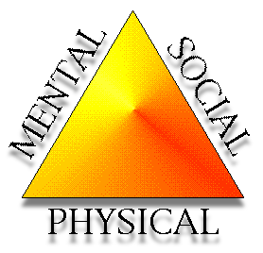8th Grade Health Study Guide: Unit 1

Terms:

* Depression
* Personal Identity
* Personality
* Role Model
* Wellness
* Anxiety
* Suicide
* Mental Health
* Emotional Health
* Social Health
* Physical Health
* Health Identity

Concepts

* Unhealthy Behaviors
* How to express emotions in a positive and negative way
* Beach Ball
* Character Traits
* How to be Healthy
* Health Triangle
* How to help someone who is depressed/suicidal
* What to do for yourself if you become depressed
* Warning signs for suicide

You can access the textbook online through ConnectEd.