**SMOOTHIES**



**Kitchen: Strawberry Banana Smoothie:**

***Ingredients:***

½ bag frozen strawberries

1 banana

1 c. strawberry yogurt

2 c. milk

**L**

**Kitchen: Raspberry Orange Smoothie:**

***Ingredients:***

¾ bag frozen raspberries

1 c. raspberry yogurt

¾ c. orange juice

1 ½ c. milk

**Y**

**Kitchen: Berry Smoothie:**

***Ingredients:***

½ bag of frozen blueberries

½ bag of frozen strawberries

1 c. strawberry yogurt

1 c. milk

½ c. orange juice

1 T. sugar

**Directions for ALL Smoothies:**

1. Measure ingredients properly
2. Combine ingredients in the blender
3. Blend to the right consistency
4. Taste test!

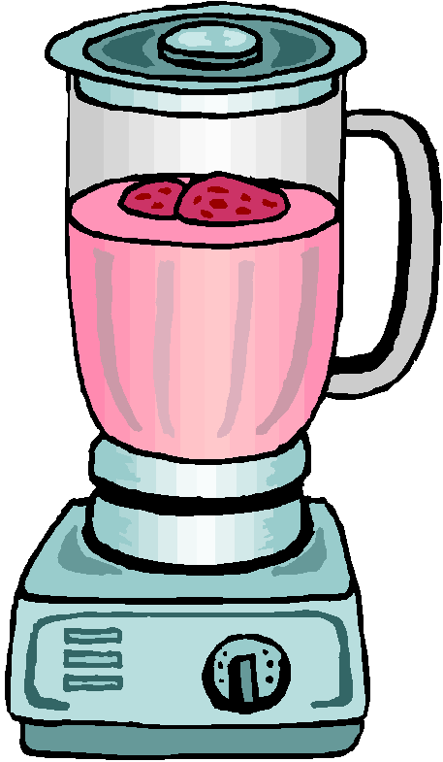

**N**

**Kitchen: Tropical Smoothie:**

***Ingredients:***

¾ c. almond milk

½ banana

1 c. frozen pineapple

2 large handfuls of spinach

Ice

**X**

**Kitchen: Refreshing Green Kiwi Smoothie:**

***Ingredients:***

½ cucumber

1 banana

4 kiwi – peeled or not peeled

2-3 handfuls of spinach

